# **PDF**

Plastics Derived Fuel

PDF

Summary

Sample pictures

### Summary

Plastics-derived fuel (PDF) is a fuel produced from various types of selected plastics, categorically excluding PVC. It constitutes the non further recyclable portion of Municipal Solid wastes (MSW), industrial wastes or commercial wastes.

|  |  |
| --- | --- |
| **Material** | **Plastics Derived Fuel (PDF)** |
| Description | produced by collection and baling of non-recyclable plastics (**not including PVC**), labels, and other soft plastics materials. |
| Packaging | Bales, abt cm 70x120 (indicative, any industry standard size will do) |
| Aspect | Solid |
| Single pieces size | Up to 40-50 cm each |
| Classification | EWC code 19.12.04  HS Code (TARIC) 39129080  Annex VII regimen, green list |
| Recovery | Strictly delivered for recovery by Basel convention method R1 (energy recovery). Final plant must be certified for R1 operations. |
| Shipment | Preferably bulk baled in 2000-2500 metric tons vessel;  Optionally bulk baled in 40’ sea containers (abt 20 metric tons per box) |

### 

### Sample pictures

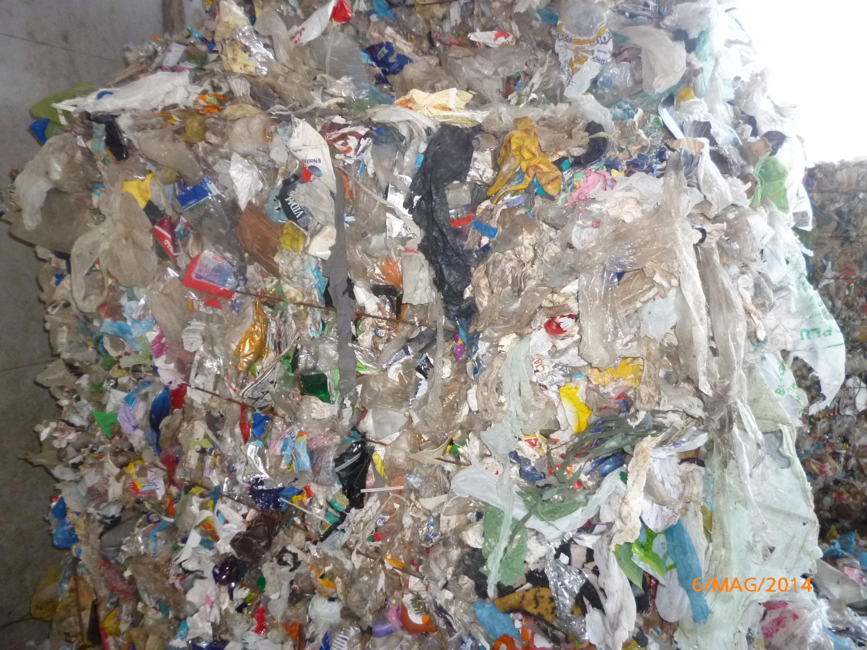

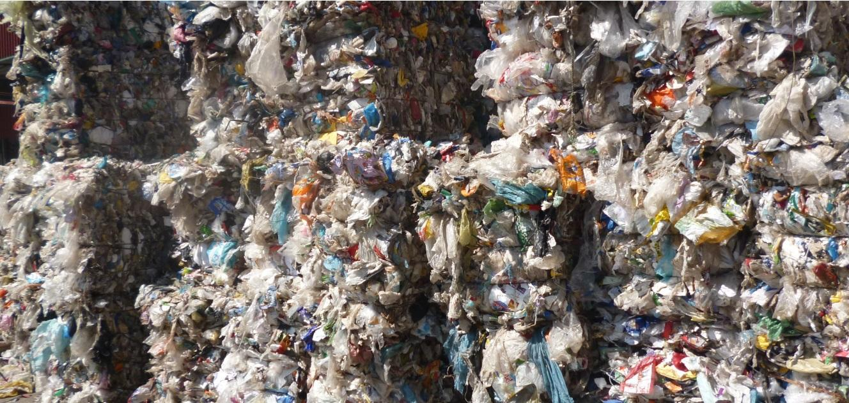

[temizevren@greensley.eu](mailto:temizevren@greensley.eu)

[www.greensley.eu](http://www.greensley.eu)